Assignment-05
Task-01:
Prompt: # I Want to generate a python code that collects user data (name,age, email) as dynamic input. Store the data in variables and dispaly a confirmation message.
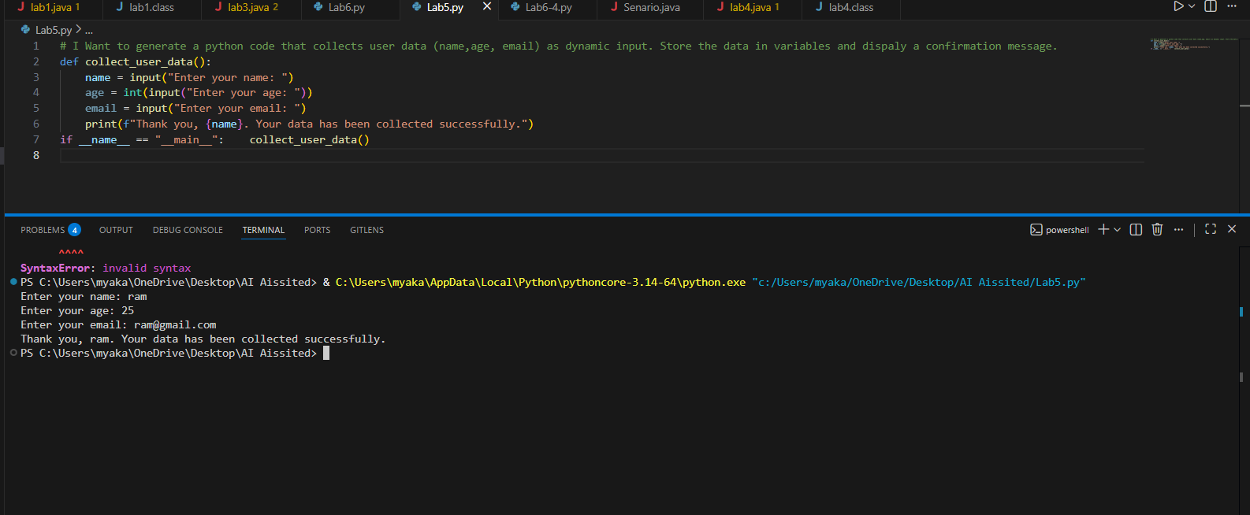
Task-02:
Prompt:
# I want to create a python function that performs basic sentiment analysis on a given text input. Use a simple approach by counting positive and negative words.
# Analyze potential biases in this sentiment analysis approach.
# Add comments or code changes that explain how to reduce bias, such as balancing datasets, removing offensive terms, or noting cultural limitations.

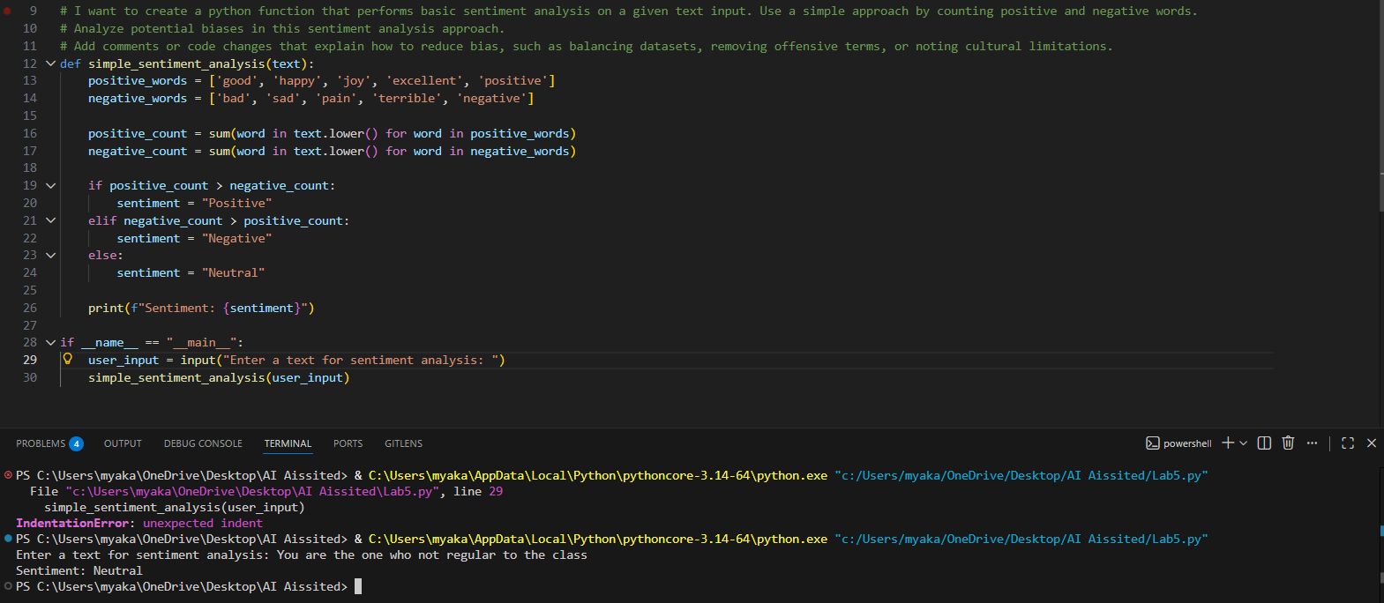

Task-03:
Prompt:
# I want to create a program recommends products to users based on their past purchase history.Use simple logic such as frequency or category matching.
# Add transparency by explaining why products are recommended,include fairness checks to avoid favoritism,and allow user feedback on recommendations.

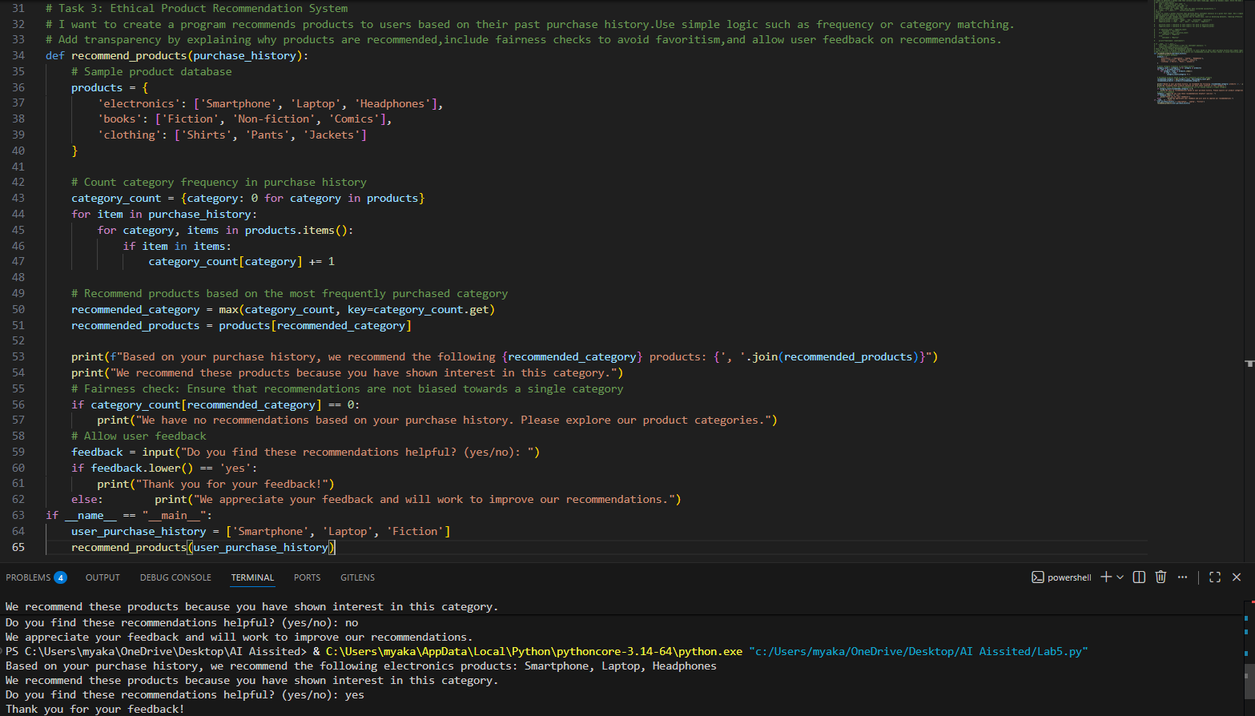
Task-04:
Prompt: # Generate Python logging functionality for a web application. Include logs for user actions such as login attempts and page visits.
# Ensure that the logging system does NOT record sensitive information such as passwords, emails, or personal identifiers.Add comments explaining ethical logging practices and privacy protection.
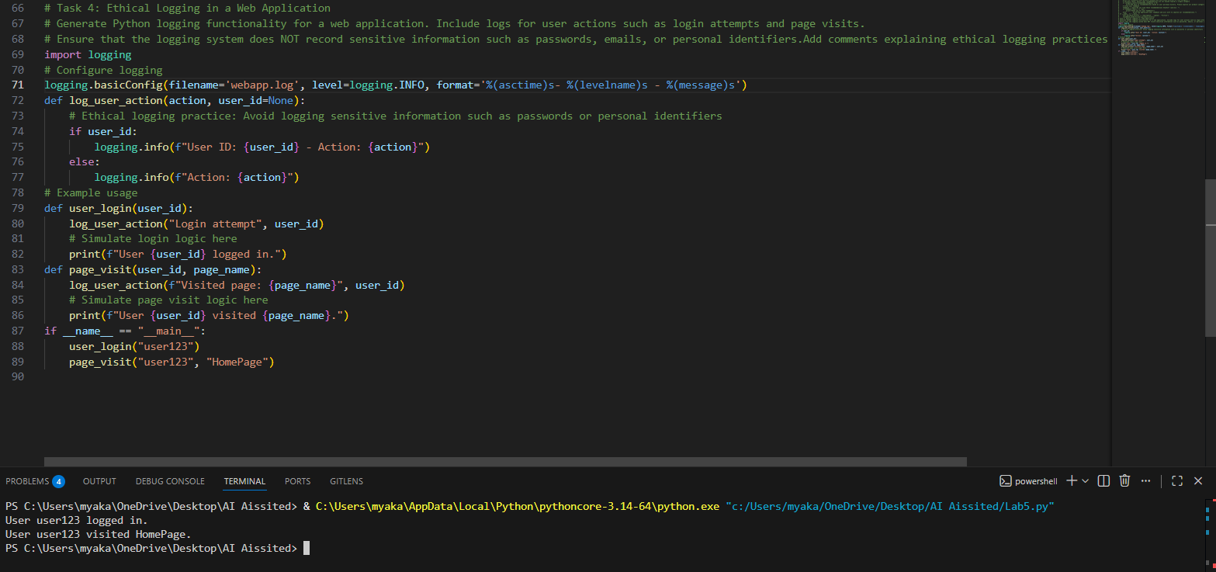
Task-05:
Prompt:
# Generate a simple machine learning model in Python using scikit-learn (for example, a classification model).Include data loading, training, and prediction steps.
# how to use the model responsibly.Include points about explainability, accuracy limitations,bias risks, fairness considerations, and appropriate use cases.
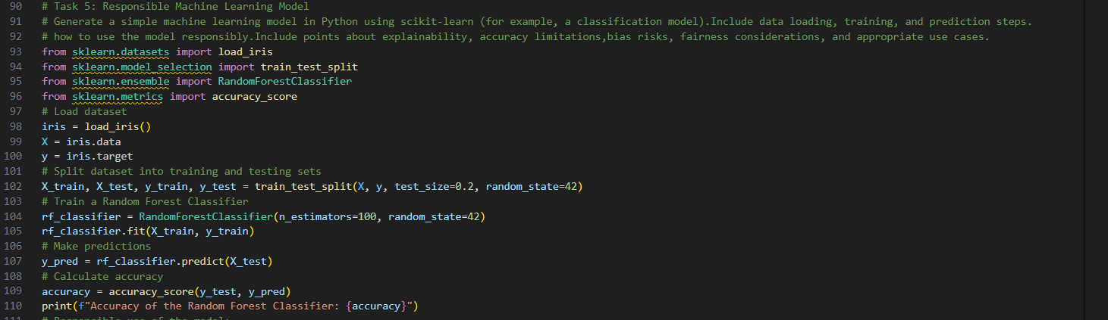
Code Explanation:
# The code above consists of five tasks that demonstrate various programming concepts and ethical considerations in software development.
# Task 1 collects user data (name, age, email) and displays a confirmation message. It emphasizes the importance of collecting data responsibly and ensuring user consent.
# Task 2 performs basic sentiment analysis by counting positive and negative words in a given text. It highlights potential biases in sentiment analysis and suggests ways to reduce bias, such as balancing datasets and removing offensive terms.
# Task 3 recommends products based on past purchase history using frequency or category matching. It emphasizes transparency in recommendations, fairness checks to avoid favoritism, and allows user feedback to improve the recommendation system.
# Task 4 implements ethical logging in a web application, ensuring that sensitive information is not recorded. It explains ethical logging practices and the importance of privacy protection.
# Task 5 demonstrates a simple machine learning model using scikit-learn. It emphasizes responsible use of machine learning models by discussing explainability, accuracy limitations, bias risks, fairness considerations, and appropriate use cases.

